CS-114 - Fundamental of Programing

Lab# 8

**Course Instructor:** Dr Khwaja Fahad Iqbal

**Lab Instructor:** Muhammad Affan

## Student Name: Muhammad Hanzla Masood

**CMS ID: 463722**

**Task 1:**

#include <bits/stdc++.h>

using namespace std;

float average(const float a[], int size){

float sum=0.0f, average=0.0f;

for (int i=0; i<size; i++){

sum+=a[i];

}

average=sum/size;

return average;

}

int main(){

float a[10];

int size=10;

cout<<"Input the values in the array: ";

for (int i=0; i<size; i++){

cin>>a[i];

}

float ans=average(a, size);

cout<<"The average of the values is "<<ans;

return 0;

}

**Task 1 Output:**

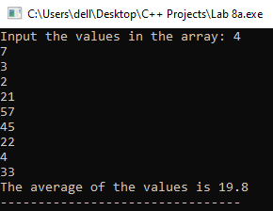

**Task 2:**

#include <bits/stdc++.h>

using namespace std;

int main(){

int a[5];

cout<<"Input 5 integers: ";

for(int i=0; i<=4; i++){

cin>>a[i];

}

for(int i=1; i<5; i++){

for(int j=0; j<=3; j++){

if (a[j]>a[j+1]){

swap(a[j],a[j+1]);

}

}

}

cout<<"The integers in ascending order are: \n";

for(int i=0;i<=4;i++){

cout<<a[i]<<" ";

}

return 0;

}

**Task 2 Output:**

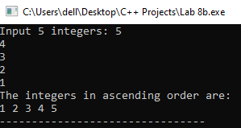

**Task 3:**

#include <bits/stdc++.h>

using namespace std;

int main(){

int a[5];

cout<<"Input 5 integeres: ";

for(int i=0; i<5; i++){

cin>>a[i];

}

for (int i=0; i<4; i++){

int min=a[i], offset=i;

for (int j=i+1; j<5; j++){

if(min>a[j]){

min=a[j];

offset=j;

}

}

if(i!=offset){

swap(a[i], a[offset]);

}

}

cout<<"The integers in ascending order are: \n";

for(int i=0; i<5; i++){

cout<<a[i]<<" ";

}

return 0;

}

**Task 3 Output:**

